Resource Group
2.1 What is a Resource Group?
A Resource Group in Azure is like a folder that holds all the resources (services) related to a project or app.
For example:
If you build a website, you might have:
- A Virtual Machine (VM) for the web server
- A Storage Account for images
- A Database for user data
You can put all of these inside one Resource Group — making it easier to manage, monitor, and delete them together.
2.2 Create a Resource Group
Sign in to the Azure Portal
In the search menu, search for Resource groups.
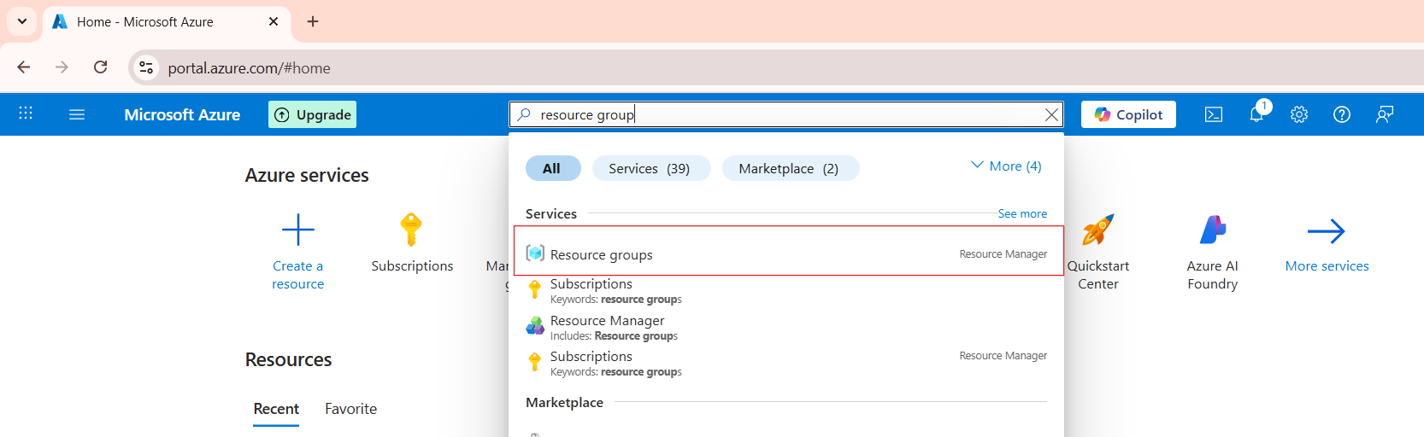
Click on the resource group and click on the create button
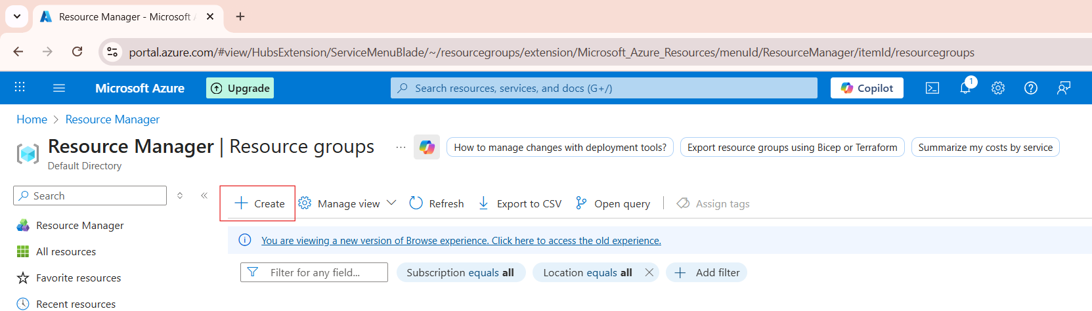

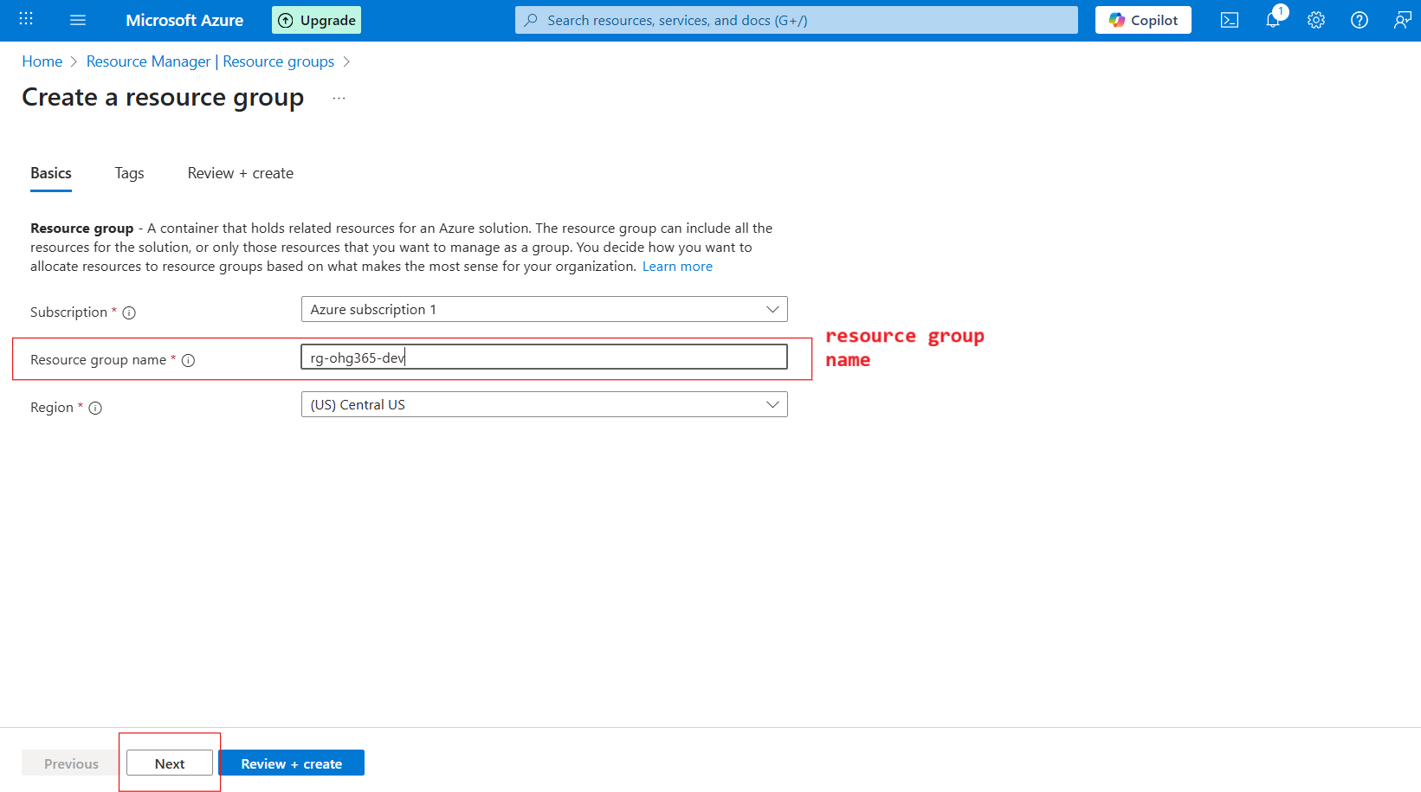

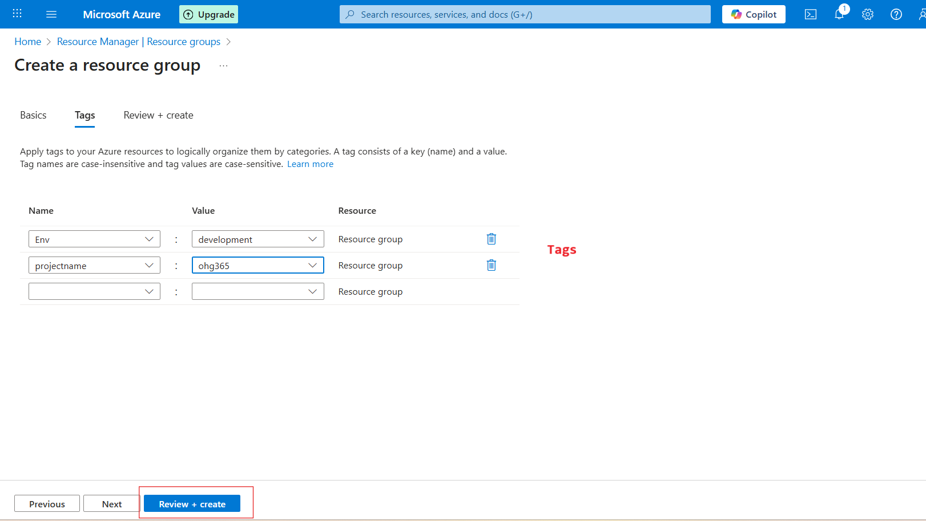

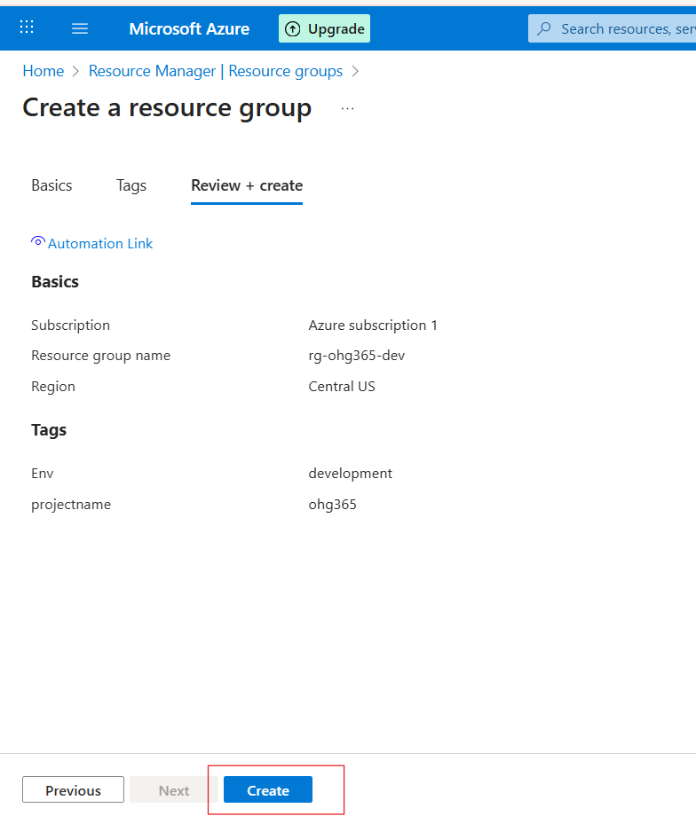
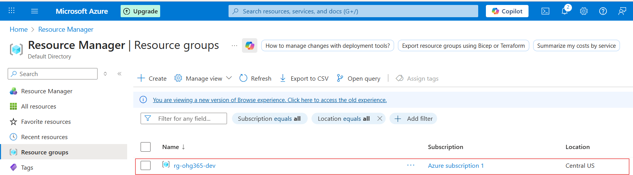

Overview of resource group:
Name: rg-ohg365-dev → This is your Resource Group’s name.
Usually, names include clues about the project or environment:
- rg = Resource Group
- ohg365 = Project or team name
- dev = Environment (like dev, test, or prod)
Buttons:
- ➕ Create: Add new Azure resources (like VMs, storage, databases).
- ⚙️ Manage view: Customize how your resources list looks.
- 🗑️ Delete resource group: Deletes the entire group and all its resources (be careful!).
- 🔁 Refresh: Updates the view if new resources were added.
- 📤 Export to CSV: Export your resource details (helpful for reports).
- 📊 Open query: Create or run custom filters using Azure Resource Graph.

